HIPPA, Privacy Practices and Email Consent

This notice describes how medical information about you may be used and disclosed and how you can get access to this information.

This Notice of Privacy Practices describes how we may use and disclose your protected health information (PHI) to carry out treatement, payment or health care operations (TPO) and for the other purposes that are permitted or required by law. It also describes your right to access and control your protected health information. Protected Health Information (PHI) is information about you, including demographic information, information that may identify you and relate to your past, present or future physical or mental health or condition and any related health or behavioral health services.

- Uses and disclosures of Protected Health Information (hereafter denoted as “PHI”)
- Your protected health information may be used and disclosed by your Licensed Clinical Professional Counselor or School Psychologist, physician, the office staff and others outside the office which are involved in your care or treatment for the purpose of providing health or behavioral health care services to you, to pay your health care bills, to support the operations of health care providers or any other use required by law.
- TREATMENT: We will use and disclose the your PHI to provide, coordinate or manage your health or behavioral health care or any other related services. This includes the coordination and management of your health care with a third party. For example your PHI may be provided to a health care professional with whom you have been referred to ensure the necessary information is available to diagnose and treat you.
- PAYMENT: Your PHI will be used as needed to obtain payment for your health care and/or behavioral health care services.
- HEALTHCARE OPERATIONS: Your PHI may be disclosed as needed in order to support the business practice of Sweetgrass Counseling/Noelle Naiden LCPC or your other health/behavioral health provider practices. This include but are not limited to, quality assessment, training of employees or graduate students, licensing or other business activities. This allows us to call you by name if you are in a waiting room or hallway setting. We may use your PHI to contact you and remind you of your appointment.
- We may disclose your PHI under the following situations as required without your authorization: Public Health issues, Communicable Disease, Health Oversight, Abuse and Neglect, FDA requirements, Legal Proceedings, Law Enforcement, Coroners. Under the law we must make disclosures to you when required by the Secretary of the Dept. of Health and Human Services for investigations or to determine our compliance with the requirements of Section 164.500.
- Other permitted uses are only by consent.

YOUR RIGHTS: the following is a statement of your rights with respect to your PHI:
- You do not have a right to inspect any psychotherapy notes or information compiled in reasonable anticipation or use in a civil, criminal, or administrative action or proceeding.
- You have the right to request a restriction of your PHI: You can ask that part or all of your PHI not be disclosed for the perpose of treatment, payment or healthcare/behavioral healthcare operations. Noelle Naiden LCPC/Sweetgrass Counseling will not disclose personal information to your family or friends without an explicit release from you. You must inform us of any other restrictions you want and to whom any restrictions apply.
- Noelle Naiden LCPC has the right to refuse to agree to any restriction you request, if I do this you have the right to find another behavioral health care provider.
- You have the right to receive confidential behavioral health care or health care information by an alternative means or at an alternative location. You have the right to obtain a paper copy of this notice from us upon request even if you have agreed to accept notification electronically.
- You have the right to have your physician or other health care/behavioral health care providers amend your PHI . If Noelle Naiden LCPC denies your request for an amendment you have the right to write a rebuttal and submit a statement of disagreement. If this occurs Noelle Naiden LCPC may write a rebuttal to your statement and provide you with a copy.
- You have a right to receive an accounting of disclosures we have made of your PHI.

Noelle Naiden LCPC & Sweetgrass Counseling Services reserves the right to change this form at any time and to notify you by mail.

EMAIL CONSENT

- HIPPA stands for Health Insurance Portability and Accountability Act. It was passed in 1996.
- Information stored on computers used in this practice is all encrypted.
- Information which comes from “sweetgrasscounselingservices.com” email address is fully encrypted.
- Other information may be encrypted through use of an add-on program such as Virtru or Hushmail.
- Most email services do not encrypt email – encryption is like putting a letter in an envelope and sealing the envelope.
- Text messaging is not encrypted and can’t be fully protected. Thus this practice uses text messaging only for scheduling and changing appointments.
- Email and text are popular ways to communicate, the federal government has provided HIPPA guidance for these two mediums on page 5634 at http://www.gpo.gov/fdsys/pkg/FR-2012-01-25/pdf/2013-01073.pdf

Federal Guidelines state: if a patient is made aware of the risks of unencrypted email and that patient provides consent to receive information via email then a health entity may send the patient personal medical/health/behavioral health information via unencrypted email.

Please indicate your preference below:

OPTION 1: ALLOW unencrypted email.

I understand the risks of unencrypted email and do hereby give permission to Noelle Naiden LCPC & Sweetgrass Counseling Services to send me personal health information via unencrypted email.

__________________________________ _____________ __________________________ ______________________________________

Signature Date Printed Name Print your email address clearly.

OPTION 2: DO NOT ALLOW unencrypted email.

I do not wish Noelle Naiden LCPC & Sweetgrass Counseling Services to receive personal health information by email.

__________________________________ _____________ __________________________ ______________________________________

Signature Date Printed Name Print your email address clearly.

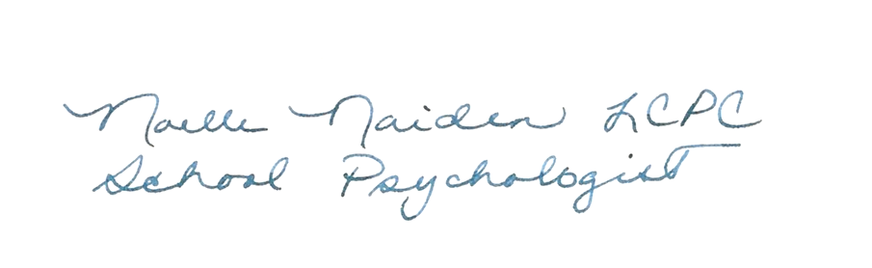

____________________________________________________________________________

Noelle Naiden LCPC Date

