CONTACT INFORMATION

Your name: ________________________________________________________________________________________

Mailing Address: ____________________________________________________________________________________

___________________________________________________________________________________________________

Primary Phone Number: ___________________ cell landline Accept Text? Yes No

Second Phone if applicable _________________ cell landline Accept Text? Yes No

Contact email: ________________________________________________________________________________________

Your insurance information: Please present your card for copying.

Insurance Company: ________________________________ Policyholder’s Name ___________________________________

Policyholder Birthdate and Social Security Number _________________________ SSN ___________ ______ ____________

Plan Number: ________________________________________ Group Number: ____________________________________

Name of identified client _________________________________________________________________________________

Client’s Social Security Number: ________ _____ ___________ Client’s date of birth: _____________________________

Client’s physical address (required) _________________________________________________________________________

Your relationship to identified client: ________________________________________________________________________

If the identified client is a child are you the custodial guardian or parent? ____________________________________________

Is there currently a question about primary custody or a divorce in process? Yes No

Briefly, what brought you in today:

Agreement to Pay for Professional Services,

Assignment of Benefits and Release of Information

I, the client (or person acting for the client), request that the therapist named below provide professional services to myself and (if

another person is also involved) and the following person or persons: _______________________________________________

Agreement to pay:

I agree to pay the following fees or as contracted/negotiated with me or my insurance company:
  - $140 (+ $20 for interactive complexity when it applies) per session
  - $250 per hour for diagnostic interview and assessment

I agree I am responsible for the charges for services provided by this therapist to me (or this client), although other persons or insurance companies may make payments on my or this client's) account.

Assignment of Benefits: I authorize my health insurance company to make payment directly to Noelle Naiden LCPC, PLLC, for benefits covered by my insurance contract.

Release of Information: I grant Noelle Naiden, LCPC, PLLC, authorization to release any information necessary for the completion of all claims relating to counseling services provided. This information may be released to my insurance company or others providing third party reimbursement for these services.

Insurance Responsibility

It is your responsibility to know what your insurance covers, your deductible and what your copay amount.

If your insurance policy changes you are responsible for notifying me. Failure to do this may result in you having to pay in full for sessions which are not covered.
- You are responsible to inform me if your insurance policy has changed. If you don’t you will be liable for the full amount for every hour following, 140.00 per session.
- It is your responsibility to know and understand your policy limits.

Copayments are expected at time of service. Be prepared to pay the copayment at the beginning of the session each time you come to see me. Know your copayment – it will be on your insurance card.

Medicaid copayment exception:
- Medicaid clients owe a $4.00 copay for each visit. This is required by the State of Montana and billed after the session billing goes through the state.
- You will get a balance due statement for applicable copayments. You are expected to pay the balance, in full, when the bill is received. I can take credit and debit cards.

Delinquent Accounts

Payment for bills is due within 7 days of receipt, please pay on time.

An account is delinquent if it is not paid within a 90 day period.

In the event I have not paid my bills I agree to the following interest agreement on the balance due:

Each 30 days no payment is made an interest rate increase occurs on the balance –30 days of no interest, 5% for the next 30 days and 10% for the final 30 days. At that point the bill will be referred to a collection agency.

If it becomes necessary to refer an account to a collection action I agree to pay the actual balance plus any fee issued by the collection agency (usually 30 to 50% of the owed balance and to pay any attorney fees incurred.

______ I agree to the terms described.

Initial

Missed Appointments

Patients are allowed two appointments missed on short notice. After that you are responsible for the full hourly amount of 140.00.

Medical service providers must schedule time in advance – cancel your appointments a day in advance.

If a unique circumstance comes up please talk to me about it ahead of time if possible. People with a pattern of absences, “illnesses” and “problems” will be dropped from my practice and not allowed to return.

If you have a sudden event or acute illness and must cancel, or need to reschedule without notice

please text me directly: 406-640-3984

I understand the missed appointment policy.

________Initial

Records

Record keeping are required by insurance companies and the law.

These notes are the sole property of Noelle Naiden LCPC and Sweetgrass Counseling Services. You have the right to request to see psychotherapy notes, you do not have the right to have a copy of them, per HIPPA regulations.

Scheduling Appointments,:

Plan on coming weekly and select a time you are able to keep consistently.

Hours are 9 to 5 on Tuesday, Wednesday and Thursday. After school hours fill up quickly and are kept for months.

_______ Initial

Videotaping:

Videotaping is required in the DIR model– brief videos are analyzed, sometimes on the spot, to determine what makes a client operate at a higher functioning level and what environment events make them have more difficulty. These are brief, 2 or 3 minute segments where I can show you specifically what your child or partner does to stay regulated and connected or what causes them to “have a meltdown.” This is a normal part the DIR process. Videos are also used to train others. Circle your preference.

YES NO I agree to videotaping and will allow tapes to be used in training other professionals.

YES NO I give permission for these sessions to be videotaped and do not give permission for use in trainings.

NO I do not give permission for any videotaping.

You may terminate this videotaping agreement at any time by informing me in a hard copy letter that includes your signature and a date. Notifying me by email does not terminate this agreement because I have no way of officially verifying your email. You may also terminate this agreement by calling and talking to me.

Sweetgrass Counseling/ Noelle Naiden LCPC is a private practice. Emergency services are not provided, calls or text messages may not be returned during off hours.

Your signature below indicates you agree to the provisions in this contract, agree to assign benefits from your insurance, and have read and understood its requirements.

Print name: _________________________________________________________

Signature: __________________________________ Today’s Date: __________________

If applicable: Relationship to the client ___________________________________

If you only agree to some of the above please indicate that below:

________“I understand and accept this agreement except where I have indicated exceptions above via my responses.”

Initial

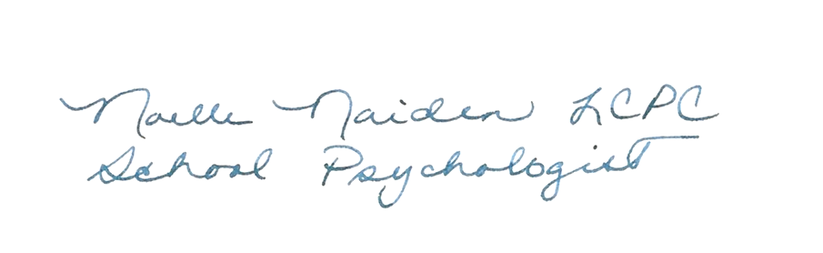

____________________________________________________________________________

Noelle Naiden LCPC Date

Notes or other comments may be added below:

